Linear Regression from Scratch Statistical Approach

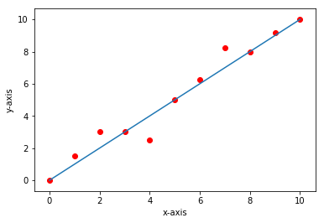

**The Theory**

Linear Regression is the process of fitting a line to the dataset.

**Single Variable Linear Regression**

**The Mathematics**

The equation of Line is

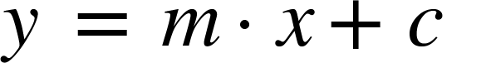

Where,

y = dependent variable

X = independent variable

C = intercept

The algorithm is trying to fit a line to the data by adjusting the values of m and c. Its Objective is to attain to a value of m such that for any given value of x it would be properly predicting the value of y.

There are various ways in which we can attain the values of m and c

1. Statistical approach
2. Iterative approach

In this post we are discussing Statistical approach. If you find the derivation too long you can take look ar final m and c formulas.

We were given data, set of x and y values and we were asked to find a line which best fits that which means mathematically we should be able to fine the slope and c values of the line to describe the line.

The derivation to the slope and intercept values of the line

The equation of the Line is

Which means for a particular value of x, let us say xi the value of y would be yi = m*xi + c

For x1 value of x y1 value of y is obtained,

For x2 value of x y2 value of y is obtained,

And goes on

On summating all these values into one equation, it can be written as,

The objective is to solve equation 1 and 2 to attain the values of c and m

On solving the c term in Equation 1, it can also be written as,

Rewriting it as,

Substituting the value of m in Equation 2

Now only c is there in Equation 3, solving for c

Step1,

Step2,

Step 3,

On multiplying both numerator and denominator by -1

To calculate the value of m taking the value of c and substituting in Equation -1,

Equation 4 have only one parameter m, so solving for m,

On expanding RHS and cancelling terms,

The value of m,

The values of c and m are,

We use the m and c formulas obtained in derivation in the code.

**The Dataset**

Dataset consists of two columns namely X and y

Where

For List Price Vs. Best Price for a New GMC Pickup dataset

X = List price (in $1000) for a GMC pickup truck

Y = Best price (in $1000) for a GMC pickup truck

The data is taken from *Consumer’s Digest.*

For Fire and Theft in Chicago

X = fires per 100 housing units

Y = thefts per 1000 population within the same Zip code in the Chicago metro area

The data is taken from U.S Commission of Civil Rights.

For Auto Insurance in Sweden dataset

X = number of claims

Y = total payment for all the claims in thousands of Swedish Kronor

The data is taken from Swedish Committee on Analysis of Risk Premium in Motor Insurance.

For Gray Kangaroos dataset

X = nasal length (mm ¥10)

Y = nasal width (mm ¥ 10)  
for a male gray kangaroo from a random sample of such animals

The data is taken from Australian *Journal of Zoology*, Vol. 28, p607-613.

[Link to All Datasets](http://college.cengage.com/mathematics/brase/understandable_statistics/7e/students/datasets/slr/frames/frame.html)

**The Code**

The Code was written in three phases

1. Data preprocessing phase
2. Training
3. Prediction and plotting

**The data preprocessing phase**

**Imports**

Numpy import for array processing, python doesn’t have built in array support. The feature of working with native arrays can be used in python with the help of numpy library.

Pandas is a library of python used for working with tables, on importing the data, mostly data will be of table format, for ease manipulation of tables pandas library is imported

Matplotlib is a library of python used to plot graphs, for the purpose of visualizing the results we would be plotting the results with the help of matplotlib library.

Math library is import for calculating powers of numbers.

<Insert Code Cell One>

**Reading the dataset from data**

In this line of code using the read_excel method of pandas library, the dataset has been imported from data folder and stored in dataset variable.

<Insert Code cell Two>

On viewing the dataset, it contains of two columns X and Y where X is dependent variable and Y is Independent Variable

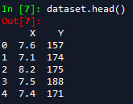

X is an independent variable

Y is dependent variable Inference

For x-value of 7.6 ,157 y-value

for x-value of 7.1 ,174 y-value

And goes on

**Creating Dependent and Independent variables**

The X Column from the dataset is extracted into an X variable of type numpy, similarly the y variable

X is an independent variable

Y is dependent variable Inference

<Insert Code cell 4>

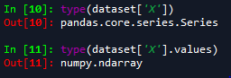

On input 10 it would result in a pandas Series object

So, values attribute is used to attain an numpy array

**Visualizing the data**

The step is to just see how the dataset is

On visualization the data would appear something like this

<Insert Code cell 6>

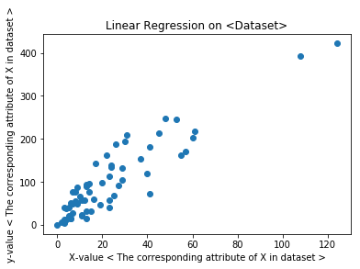

Each point on the plot is a data point showing the respective list price on x-axis and Best Price on y-axis

The X and Y attributes would vary based on dataset.

**Splitting the data into training set and test set**

We are splitting the whole dataset into training and test set where training set is used for fitting the line to data and test set is used to check how good the line if for the data.

<Insert Code Cell 7>

**The Training phase**

**Computing the values of sigma**

As per the derivation formula we are computing the values of sigma x sigma x^2 sigma y sigma x*y

n is the number of terms in the dataset

<Insert Code Cell 8>

**The Prediction phase**

**Predicting the Results**

By the knowing the slope and intercept values of linear regression model we are trying to predict the values of test data. Y_pred variable contains all the predicted y-values of the test x-values.

<Insert Code Cell 10>

**Visualizing the Results**

As we have predicted the y-values for a set of x-values we are visualizing the results to check how good did our line fit for our predictions.

The plot shows the red points are the data points are actual values where the blue line is the predictions.

<Insert Code Cell 11>

